Nurturing Care for 12 months to 2 years

Nutrition: (from Malawi Guidelines for Community-Based Management of Acute Malnutrition, 2nd Edition)
During the period of 12–24 months, children experience rapid growth increasing nutrient requirement. Children are prone to various infections as they interact with their surroundings, further increasing the energy they need.
-Continue breastfeeding your baby on demand both during the day and at night, to meet the nutritional needs of the baby and maintain his health and strength.
-Breastfeed first before giving other foods.
-Feed your child the same foods you feed the rest of the family and ensure that the food is chopped and moistened. Avoid sweet drinks and dessert foods like biscuits
-Feed your child at least five times per day, including three main meals and nutritious snacks between meals, such as vegetables and fruits, which are good sources of vitamin A when prepared or eaten with fat, including dark green vegetables such as chisoso, nkhwani, moringa, bonongwe, or kholowa, as well as tomatoes, eggplant, carrots, or cabbage; and fruits like oranges, passion fruit, mango, papaya, bananas, watermelon, pineapple, avocado, chikondamoyo, or chitumbuwa.
-Increase portions of protein including beans, meat, fish, and eggs.
-Increase the amount of food given to the child so that by 24 months, the child is fed 16 tablespoons of food per meal.
-Use a separate plate to feed the child and note if the child finishes the meal.
-To avoid diarrhoea and other illnesses:
    - Use a clean spoon and cup to give foods or liquids to your child.
    - Store the foods in a safe, hygienic place.
    - Wash your hands with soap and clean running water after using the toilet or washing your child’s bottom and before preparing foods and feeding your child.
    - Wash your child’s hands with soap and clean running water before eating.
Responsive Caregiving:

Be patient and actively encourage your child to eat. Avoid forcing your child to eat.

Pay attention to what your child is pointing to or telling you about. When your child asks for something and her speech is unclear, kindly repeat what she says clearly and respond to her request.

Children find security in knowing the boundaries and routine. Talk with your spouse so that you agree on the expectations in your home. Be consistent in training your child. Praise and encourage positive behavior. Teach your child not to hit, bite, or pinch. Remove your child from the situation and clearly say “no” with negative behavior.

All children should have a developmental screening between 2 to 2 ½ years of age.
Development for 12 months (from Road to Health by the Department of Health in the Republic of South Africa)
Hearing/communication | Vision and adaptive | Cognitive/behaviour | Motor skills
Uses simple gestures (e.g. lifts arms to be picked up) | Looks for toys/ objects that disappear | Imitates gestures (e.g. clapping hands) | Stands with support
Has one meaningful word (dada, mama although sounds may not be clear) | Looks closely for toys/ objects and pictures | Understands ‘no’ | Picks up small objects with thumb and index finger
Imitates different speech sounds

Development for 18 months (from Road to Health by the Department of Health in the Republic of South Africa)
Hearing/communication | Vision and adaptive | Cognitive/behaviour | Motor skills
Understands names of at least two common objects (e.g. cup) | Looks at small things and pictures | Follows simple commands (e.g. ‘come’ and ‘here’) | Walks alone
Uses at least 3 words other than names |  |  | Uses fingers to feed

Make an appointment to see the pediatrician for further evaluation if your child cannot do the milestones listed above at 12 and 18 months.
Opportunities for Early Learning:
Play- Give your child things to stack up, and to put into containers and take out. Sample toys: Containers that fit inside each other and can be stacked, clothespins and container.
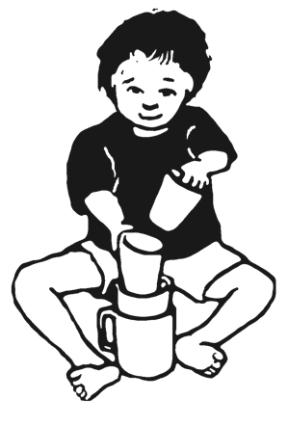

Communication- Ask your child simple questions. Respond to your child’s attempts to talk. Show and talk about nature, pictures, and things.

Security and Safety:
Supervision- Stay within an arm’s length of your child and watch him closely when near the road, fire, or water. Teach your child to hold your hand and how to avoid dangerous situations.

Medicines and Cleaning Supplies- Keep medicines and cleaning supplies locked away and out of reach of children. Go to the clinic right away if your child takes these.

Car Seats- Your child needs to be in a car seat in the back of the car facing the back every time you are in the car.
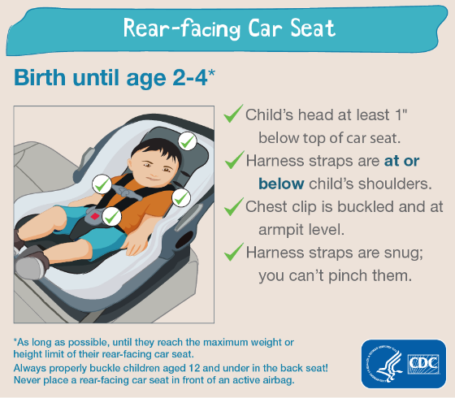

Choking- Don’t let your child play with small objects such as caps, coins, or hard candy. If he chokes, turn him across your arm on his abdomen with his head pointing down and hit his back between the shoulder blades with the heel of your hand several times until the object comes out.

Health:
Teeth- Brush your child’s teeth morning and night with a soft toothbrush. Use a rice-sized amount of toothpaste with fluoride in it. Do NOT let your child go to sleep with a bottle or any sweet drink like Sobo, which will sit on the teeth and cause cavities.

Fever- Any time your child has a fever, have your child checked for malaria. The best way to prevent malaria is to sleep under an insecticide treated mosquito net every night. Viruses are another common cause of fever. Viruses get better without antibiotics. Do NOT give antibiotics unless prescribed by your doctor.

Diarrhea- If your child has diarrhea then increase fluids right away. Mix 1 packet of ORS with 1 liter of clean water. Give your child 50-100 ml after each diarrhea stool. Go to the clinic if fever, blood or mucus in the stools, or signs of dehydration (decreased urine output, sunken eyes, or dry mouth).

Worms- Intestinal worms can cause malnutrition, abdominal pain, and constipation. Be sure to take your child for deworming every 6 months.

Immunizations- Your child should get the 2nd MR vaccine at 15 months of age.

For more information for caring for your child refer to www.healthyglobalkids.com

