Nurturing Care for 6 months to 9 months

Bring your baby in to the clinic for a developmental screening at 9 months of age.
Nutrition: (from Malawi Guidelines for Community-Based Management of Acute Malnutrition, 2nd Edition)
From 6 months onward, breast milk alone is not enough to meet the nutritional requirements of a rapidly growing baby. Your baby needs complimentary feeds.
Breastfeed your baby before feeding him. Next, wash your hands and baby’s hands with soap and water. Drinking water should come to a boil to be clean enough for your baby to drink.
Start with a thick porridge (maize, rice, millet, potatoes, or sorghum) and place it in a separate bowl so you can see how much your baby eats. The porridge should be thick enough to be fed by hand.
Smile and talk to your baby as you feed him. Be patient and enjoy this time with your baby! It takes time for baby to learn to eat at first. Introduce one new food every few days.
The amount of food baby eats will gradually increase from 2-3 tablespoons per meal to ¾ to 1 full (250 ml cup or bowl) two to three times a day at 9 months. Babies still need to breastfeed up to 8 times each day and night.
Staple foods: porridge (maize, rice, millet, potatoes, sorghum), mashed banana, or mashed potato, will give your child energy.
Meat and animal products: soft meat (chicken, goat, beef), fish, or eggs once a day (at least 2 heaping tablespoons) are a good source of iron which will help make your child strong.
Legumes: beans and peas.
Fruits: mangoes, tangerines, oranges, avocado, and juice of baobab, which may protect your child from illness.
Vegetables: green leafy vegetables such as nkhwani, khwanya, and chisoso.
A variety of healthy foods will give your baby energy, strength, and help protect him from illness. Find ways to mix the foods from the major food groups. For example: Give the baby thick porridge made with different foods like: groundnut flour, mashed or pounded vegetables like nkhwani (pumpkin leaves), mpiru, or kholowa, or dried vegetable powder; meat products like mazira (eggs), mkaka (milk), or nsomba yosinjasinja (ground fish); and fruits like mashed banana or fresh fruit juice.
Responsive Caregiving: You are the most important person in your baby’s life. Pay attention to your baby’s emotions, likes and dislikes. Talk, hug, and play with your baby as you dress her, feed her, and care for her through the day.
Development for 6 months (from Road to Health by the Department of Health in the Republic of South Africa)
Hearing/communication | Vision and adaptive | Cognitive/behaviour | Motor skills
Moves eyes or head in direction of sound | Eyes move well together (no squint) | Laughs aloud | Grasps toy in each hand
Responds by making sounds when talked to | Recognizes familiar faces | Uses different cries or sounds to show hunger, tiredness, discomfort | Lifts head when lying on tummy
 | Looks at own hands

Development for 9 months (from Road to Health by the Department of Health in the Republic of South Africa)
Hearing/Communication | Vision and adaptive | Cognitive/behaviour | Motor skills
Babbles  (‘ma-ma’ ‘da-da’) | Eyes focus on far objects | Throws, bangs toys or objects | Sits without support
Turns when called |  | Reacts when caregiver leaves. Calms when he/she returns | Moves objects from hand to hand

Make an appointment to see the pediatrician if your child cannot do the milestones listed above at 6 months and 9 months.
Opportunities for Early Learning:
Play:
Give your child clean safe household things to handle, bang, and drop.
Sample toys: Container with lids, metal pot with spoon.

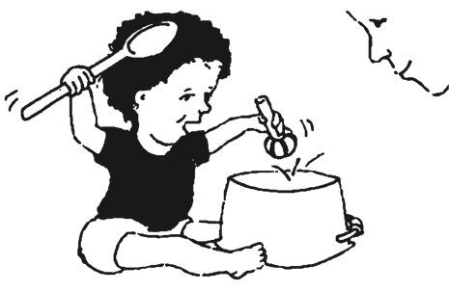

Communication:
Respond to your child’s sounds and interests. Call the child’s name and see your child respond.

Security and Safety:
Baby proof the house- Here are some ways to help make your home safer for your moving baby:
- Make sure all chemicals, cleaners, and medicines are out of reach
- Make sure all furniture is well anchored and can’t tip over if baby tries to climb on it
- Keep small items that a baby could choke on (coins, small toys, bottle caps, buttons, etc..) out of reach.
- Keep electrical cords tucked up and out of reach of baby. Make sure electrical outlets are switched off and/or covered.
- Always cover water storage buckets.

Burns- Keep hot drinks away from the edge of the table. Have someone else watch baby while cooking. Teach her to stay away from fires.

Falls- Babies fall off beds, couches, and other high surfaces at this age. Make sure baby is sleeping on a mattress on the ground or in a safe crib or cot if unattended. Teach your baby how to turn onto her stomach and safely come down from the couch or bed.

Car seats- Babies need to be in a rear facing car seat in the back seat every time you drive.
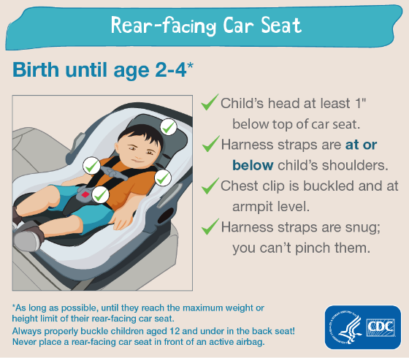

Health:
Fever- Babies at this age get childhood illnesses (chifuwa, ear infections, and gastroenteritis). Any child with a fever or vomiting needs to be evaluated as soon as possible for malaria. If there is no sign of malaria or a bacterial infection, then your doctor may advise watchful waiting. Antibiotics will not help if your child has a virus and could make things worse. DO NOT give an antibiotic unless it has been prescribed by a qualified clinician that has examined your child.

Diarrhea- Babies are more likely to get diarrhea as they begin eating foods and drinking water. Wash hands with soap and water before cooking or serving food. All drinking water should come to a full boil and be cooled before giving to baby. If your baby gets diarrhea, then increase liquids right away, preferably breast milk or oral rehydration solution. Come to the clinic if blood in the stools, fever, vomiting, or baby is not making a lot of wet diapers.

Choking- Babies at this age put everything in their mouths and can choke. If you think that your child is choking then turn him upside down and hit on his back.

For more information to care for your 6-9 month old refer to www.healthyglobalkids.com

