Birth to 1 week

Congratulations on the birth of your baby! At ABC Community Clinic we want you to know that we are here to encourage you as you become parents.

Danger Signs:
You should bring your baby back to the clinic immediately if:
- Baby is breathing one breath per second or faster or has chest in-drawing
- Baby has any fever
- Baby has convulsions
- Baby has yellow eyes, palms or soles (feet)
- Baby has no movement or only moves with stimulation
- Baby is feeding poorly or not at all
- Baby is not passing urine or stool
- Fontanelles (soft spot on the top of the head) are bulging or sunken
- Baby is vomiting
- Pus discharge or lots of bleeding from the umbilical cord
- Eye discharge

Mother should come back to the clinic immediately if:
- Heavy vaginal bleeding or foul-smelling discharge
- Severe abdominal pain
- Unexplained pain in chest or legs
- Blurred vision or severe headaches
- Difficulty breathing
- Fever or chills
- Vomiting

Nutrition:
Breast milk is the best nutrition for your baby. Breastfeeding helps protect your baby from infection, is easier to digest than formula, and even has long-term health benefits for both Mom and baby. Studies have even shown that children that had breastfed as babies scored higher on intelligence tests than children that had not been breastfed. Your baby should take nothing but breast milk by mouth until six months of age.

As you are holding your baby skin to skin offer your breast. Try to breastfeed your baby within the first half hour after birth. Your new baby should breastfed every 2-3 hours day and night. You may need to wake your baby up to breastfeed. The more your baby breastfeeds, the more milk your body will make. It takes a while for both mother and baby to learn to breastfeed so be patient with yourself and baby. Our nurses are happy to help.

The first kind of milk that comes in after birth is called colostrum. It is thick and clear. It is like medicine. It helps protect your baby from many types of sickness. This is all your baby needs until your milk comes in.

After a few days, your breasts will get full with milk. With each feeding when a baby first starts sucking on the breast, he or she will get the foremilk, which is more watery. This provides all the water a baby needs. As the breast empties your baby will get the hindmilk. This is the white milk that is full of fat and energy to help your baby grow. Your baby needs both kinds of milk, so be sure to leave baby on the breast long enough to empty the breast.

Positioning: Hold your arm under your baby so that his head is supported. His neck and body should line up so that he will approach the breast nose to nipple. Support your breast with your fingers along the chest wall and your thumb on top, not near the nipple.

Attaching: Gently touch your nipple to your baby’s lips. Wait until he opens wide, then move your baby onto the breast, aiming the lower lip below the nipple. When baby attaches well, his lower tongue will go under the breast and he will have both the nipple and some of the breast tissue in his mouth. (see picture on left below). When he sucks, he will squeeze the milk out of some of the larger ducts. His sucking will help your milk come in.

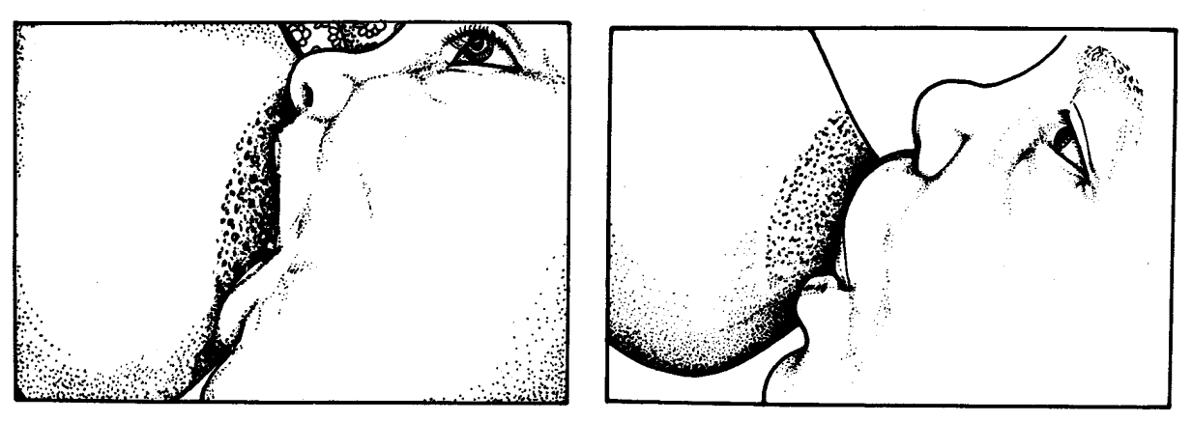
The picture on the left shows correct attachment. The picture on the right shows incorrect attachment. You should not have pain or hear clicking sounds if your baby is attached correctly.

Breastfeeding is best for baby and you. Babies who drink from bottles are more likely to get sick from diarrhea and other illnesses. It is normal for newborns to lose a little weight after birth. By two weeks of age, your baby should be back up to his birth weight and will continue gaining weight. Please talk to a nurse if you are having any trouble with breastfeeding, so we can help you.

Development
A newborn baby sees your face and hears your voice.
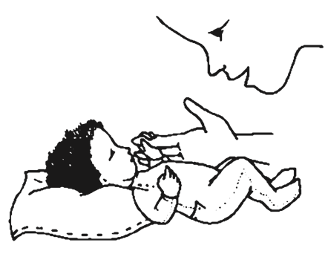

Play
Provide ways for your baby to see, hear, move arms and legs freely, and touch you. Gently soothe, stroke, and hold your child. Skin to skin is good.

Communication
Look into your baby’s eyes and talk to your baby. When you are breastfeeding is a good time.

Safety
Hand washing: Everyone should wash their hands with soap and running water before holding baby.

Safe Sleep: Babies should always sleep on their backs on a firm surface without blankets or pillows. All babies should sleep under a long-lasting insecticide treated mosquito net.

Car Seat: Your baby should be placed in a car seat in the back seat, facing the back of the car every time you get in the car.

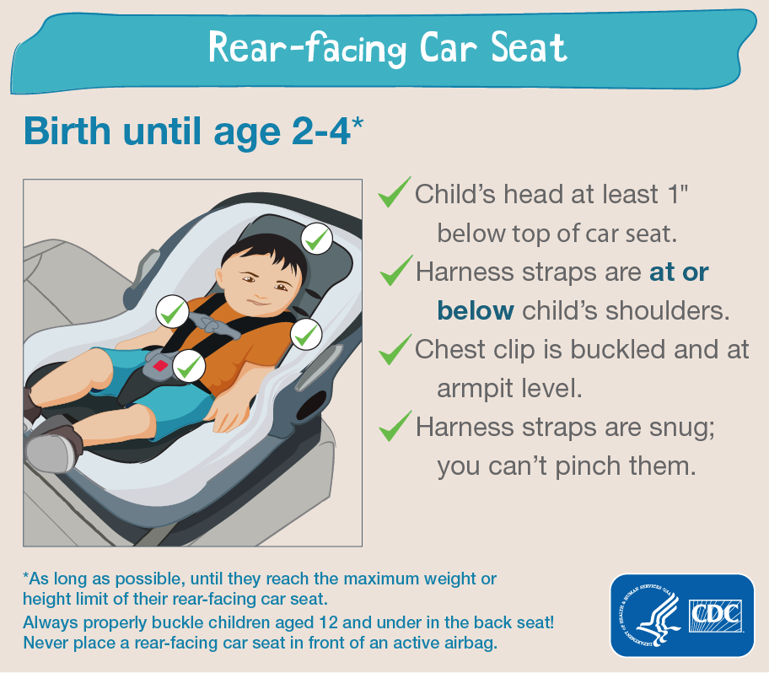

Postpartum Depression: It is common to have feelings of sadness for several months after delivery. Talk to an experienced mom, friend, or family member for encouragement and support. You may also visit your doctor for advice. If you have thoughts of harming yourself, your baby, or are unable to care for your baby then come to the clinic.

Health
Temperature: Babies have a difficult time regulating their temperature. It is important to keep baby warm, but not to over-bundle. Babies usually need just one more layer than you.

Healthy Eating: Mothers need to eat from each of the food groups, especially iron rich foods such as protein and greens. It is important for breast feeding mothers to drink lots of fluids, between 2-4 liters of water, juice, or milk each day.

Cord Care: Keep the stump clean and dry. No need to wash it with soap. Do not put any treatments on it. The stump may bleed a little bit and make a scab when it falls off. It should fall off before 3 weeks. If it drains pus or smells bad, then bring your baby to the clinic.

HIV: HIV positive mothers must continue with their HIV medicine. Baby will also be treated and scheduled for testing.

Pediatric Preventive Health Care

Newborn Exam: Before you are discharged from the hospital after delivery one of our trained staff will perform a complete newborn exam. Feel free to ask us questions during this time.

Newborn Hearing Screen: ABC Audiology clinic provides newborn hearing screening.

HIV Testing: We will test you for HIV before discharge.

Postnatal Visits: Your baby will have 3 postnatal visits (around day 3 which may be before discharge, week 1, and week 4-6). Be sure to discuss with your spouse and make a plan for contraception and family planning. Come for well-baby exam and developmental checks at 9 months and 2-2 ½ years of age.

Immunizations and Growth: The government provides immunizations each Monday and Thursday morning at ABC Community Clinic. Follow the schedule in your child health book (BCG and oral polio will be given at birth. The next immunization visit will be after your baby is 6 weeks old.) Be sure that weights get recorded at each immunization visit as well.

Health Information: We provide handouts with health information as your baby grows. You can access these handouts and more information at www.healthyglobalkids.com.

