Nurturing Care for 1 Week to 6 months

Nutrition:
Breastfeed exclusively for the first 6 months. Don’t give your baby anything else by mouth. Breast milk provides all the nutrition your baby needs.
Some babies get growth spurts at 2 weeks, 6 weeks, and 3 months of age. During this time your baby will be more hungry. Breastfeed him more often and your body will make more milk to meet his growing needs. Please let your doctor know if you are having breastfeeding troubles, questions, or concerns.
Responsive Caregiving: You are the most important people in your child’s life. Children need safe, loving, responsive relationships with parents to develop and grow. During the first few months of life keep your baby close to you as much as possible to bond with your baby. Learn your baby’s different cries and meet his needs.
Development for 14 weeks (from Road to Health by the Department of Health in the Republic of South Africa)
Hearing/communication | Vision and adaptive | Cognitive/behaviour | Motor skills
Reacts to sounds | Follows face or close object with eyes | Smiles at people | Holds head upright when held against shoulder
 |  |  | Hands are open most of the time
Development for 6 months (from Road to Health by the Department of Health in the Republic of South Africa)
Hearing/communication | Vision and adaptive | Cognitive/behaviour | Motor skills
Moves eyes or head in direction of sound | Eyes move well together (no squint) | Laughs aloud | Grasps toy in each hand
Responds by making sounds when talked to | Recognizes familiar faces | Uses different cries or sounds to show hunger, tiredness, discomfort | Lifts head when lying on tummy
 | Looks at own hands
Make an appointment to see the pediatrician for further evaluation if your child cannot do the milestones listed above at 14 weeks and 6 months.
Opportunities for Early Learning:
Play- Play and communication are important ways to help your child learn, grow, and develop.
Provide ways for your child to see, hear, feel, move freely and touch you. Slowly move colorful things for your child to see and reach for. Put your baby on his stomach for a little play time every day. Put toys just out of reach. Sample toys: Shaker rattle; Smooth key on a string.

Communication- Smile and laugh with your child. Talk to your child. Get a conversation going by copying your child’s sounds or gestures. Sing to your baby.
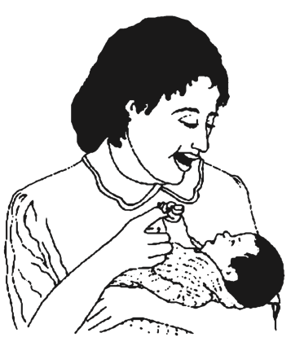

Security and Safety:
Safe sleep-
-Put your baby to sleep on his back every time you lay him down. This way baby can breathe easier and if he spits up, the liquid will drain back into the stomach tube instead of the breathing tube.
-Baby needs to be on a flat, firm surface without blankets, cushions, and pillows. Soft cushions, pillows, and blankets can suffocate a young baby. A separate baby bed or bassinet is safer than bed-sharing.
-Never put a baby to sleep on a high surface where he could roll over and fall off.
-All babies should sleep under a long-lasting insecticide treated mosquito net, especially at night.
-Babies should sleep in the same room as parents at least the first twelve months.

Burns- Don’t hold hot liquids while holding your baby. Test the bath water with your elbow or the back of your hand to make sure it is warm but not hot.

Falls- Don’t leave a baby unattended on a bed, couch, or other high surface. Even babies that are too young to roll over have managed to roll off these high surfaces.

Car seats- Place your baby in a car seat in the back seat, facing the back, every time you get in a car. Car seats protect babies from serious injury and death should you get in a car accident. Babies may fuss when you first put them in the car seat, but if you do it every time and don’t take them out while driving, they quickly adjust and often fall asleep while you drive.

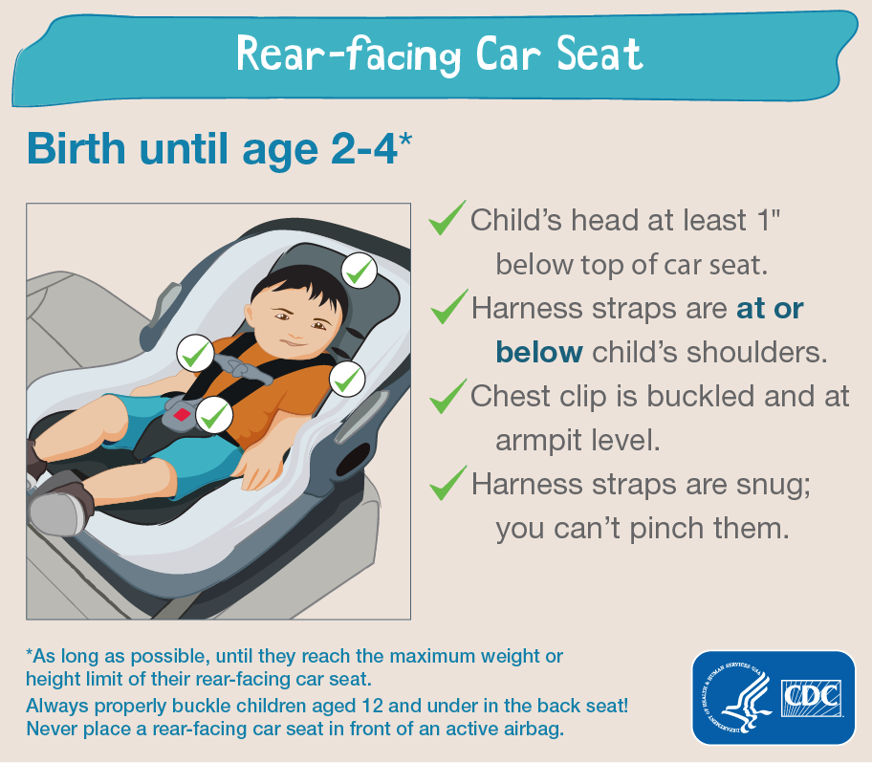

Good Health:
Postpartum depression- Over the past 2 weeks, have you ever felt down, depressed, or hopeless? Over the past 2weeks, have you felt little interest or pleasure in doing things? If the answer is yes, then talk to a trusted friend or your doctor.

Respiratory illnesses - Young babies have small airways. For this reason simple upper respiratory infections, even though they are viruses, can become more serious. If your child has a runny nose or cough, pull up his shirt and look at his ribs. If the skin is sucking in between the ribs, you hear wheezing, you see the nostrils going in and out, your baby has a fever, or your baby is breathing as fast as about a breath per second then bring your child to the clinic.

Fever- Babies under 6 months need to be evaluated at the clinic if they have a fever. It’s important to diagnose and treat malaria early.

Diarrhea- The best way to prevent diarrhea in babies is to breastfeed exclusively until 6 months of age. If your baby has diarrhea, increase feeds as you go to the clinic to be evaluated. Young babies can become dehydrated quickly.

Crying baby- It can be difficult to know what to do when your baby is persistently crying. Babies cry to let you know they are tired, hungry, bored, hot, cold, or in pain. Some babies fuss in the evenings. Ask someone else to hold the baby if you are getting overwhelmed. If it seems like your baby is in pain and you can’t find out what is going on, then bring your baby to the clinic.

Immunizations- It’s important to bring your baby to his immunization appointments starting at 6 weeks. If you are following the Malawian schedule then go directly to the government immunization sites as directed in the health passport. If you are following another country’s immunization schedule, then make a well baby appointment through ABC Clinic reception.

Go to www.healthyglobalkids.com for more information on how to care for your growing baby.

