Breastfeeding Class

Advantages of Breastfeeding | Disadvantages of Artificial Feeds
Perfect nutrients | Vitamin A deficiency
Easily digested/efficiently used | More allergy and milk intolerance
Protects against infection | More diarrhea, more persistent diarrhea, more frequent respiratory infections, obesity, increased risk of chronic diseases.
Helps bonding and development | Interferes with bonding
Helps delay new pregnancy | Mother may become pregnant sooner
Protects mothers’ health | Increased risk of anemia, ovarian cancer, and breast cancer in mother
Costs less than artificial feeds | Lower score on intelligence tests
The World Health Organization (WHO) recommends that infants should be exclusively breastfed for the first six months of life to achieve optimal growth, development, and health. At six months, when complementary foods are introduced, breastfeeding should still continue up to two years of age or beyond.
Colostrum: This milk comes in the first few days after delivery. It is thick, yellowish, or clear. It contains antibodies that fight off infection. It helps clear out the meconium (thick, black first baby poo) and helps prevent jaundice. It also contains growth factors that help the intestines mature and decreases allergies. The rich vitamin A properties decrease the severity of infections. It is important that baby gets this colostrum.
Mature Milk: This is the milk that comes in after a few days, making the breasts feel full, hard and heavy. Foremilk: This milk is produced early in the feed. It is thin and watery, providing all the water a baby needs, even in hot climates. It contains protein, lactose, and other nutrients. Hindmilk: As baby continues to feed he will get the hindmilk. This milk looks whiter because it contains more fat that the baby needs for energy. It’s important for baby to stay on the breast long enough to get both foremilk and hindmilk.
What’s Happening in Mom’s Body? In the breasts are milk producing sacks, called alveoli attached to ducts that carry the milk to larger ducts out through the nipple. There are two main hormones in the mom’s body that affect breast feeding:
Prolactin is the hormone that tells the alveoli to make milk. When the baby sucks on the breast, this sends a message to the brain to send prolactin into the blood. The prolactin causes the breast to produce the milk for the next feed. More prolactin is produced at night. In contrast to Prolactin, milk has a substance in it that slows down milk production. For Mom to produce milk in the body, the baby sucks on the breast, removing the milk that could slow down production, while at the same time causing the release of the hormone that starts making more milk. (Hormones related to Prolactin suppress ovulation which is one way frequent breastfeeding, especially at night, can delay pregnancy.)
Oxytocin is the hormone that causes the muscles to contract, causing milk to flow down the ducts and out the nipple. When the mother thinks about feeding her baby or the baby begins to suck, a message is sent to the brain and oxytocin is released causing the muscles to contract and milk to flow. It helps if mom is rested and is given plenty of time to cuddle and enjoy her baby. (This hormone also contracts the uterus. Though painful, it helps reduce blood loss after delivery.)
How is Baby Prepared to Breastfeed? Babies are born with reflexes that prepare them to breastfeed. Rooting Reflex: When you touch a baby’s lips or stroke their cheek, they will turn their head, open their mouths wide, and put their tongue down and forward. This helps the baby attach to the breast. Sucking Reflex: When something touches the roof of the baby’s mouth he will begin sucking. Swallowing Reflex: When baby’s mouth fills with milk, he swallows.
Feeding Baby: For many months you have dreamed about holding your baby in your arms, seeing his precious face, holding his tiny hand in yours. You have thought about all that you will teach him and show him. Breastfeeding is the first lesson you will teach your baby and you will be learning alongside him. As with every lesson, you want to be filled with love and patience for both you and your baby, not putting pressure on either one of you to get it perfect right away. Breastfeeding is the first of many journeys you will share with your baby. Immediately after birth, your baby will be placed on your chest. As you hold your baby skin to skin and he looks at your face, you are communicating that you love him and that he can trust you. Enjoy this time. The first half hour after birth is the best time to begin breastfeeding.
Dad and Breastfeeding: Dad plays an important role in breastfeeding. A Mom that is rested, encouraged, loved and supported will have an easier time breastfeeding. What can you do to be a supportive father?
Positioning: Hold your arm under your baby so that his head is supported. His neck and body should line up so that he will approach the breast nose to nipple. Support your breast with your fingers along the chest wall and your thumb on top, not near the nipple. Which picture below does not show good positioning?

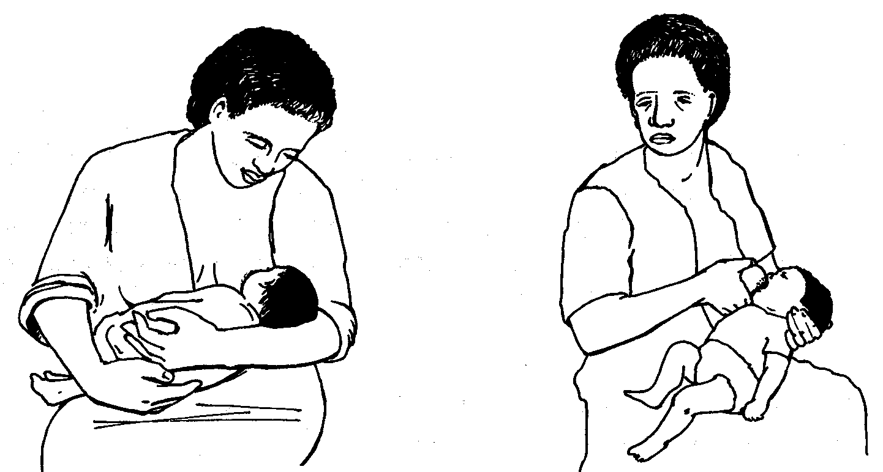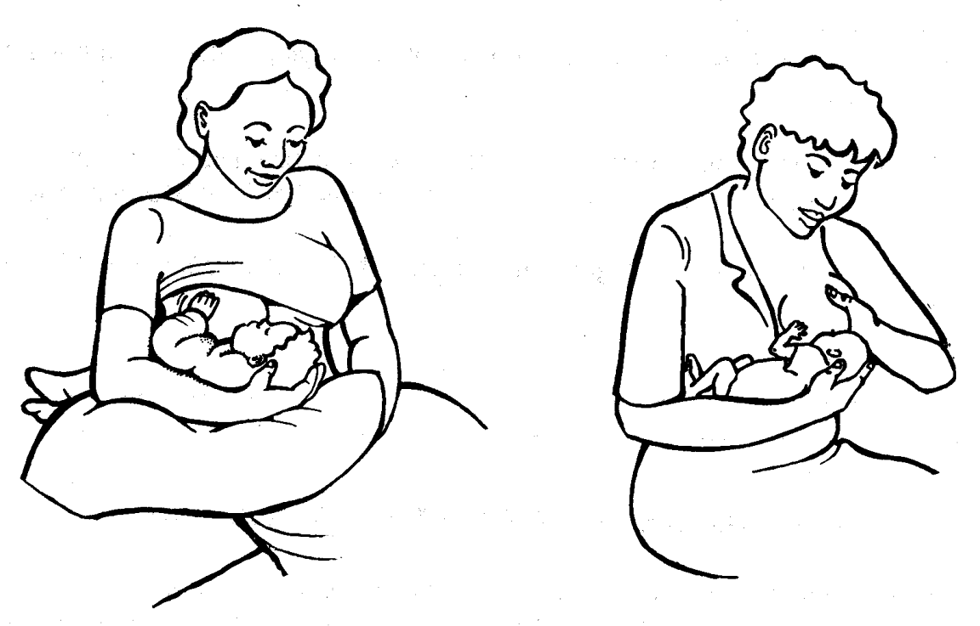

Attaching: Gently touch your nipple to your baby’s lips. Wait until he opens wide, then move your baby onto the breast, aiming the lower lip below the nipple. When baby attaches well, his lower tongue will go under the breast and he will have both the nipple and some of the breast tissue in his mouth. When he sucks, he will squeeze the milk out of some of the larger ducts. You should see more of the areola (dark skin around the nipple) above the nipple than below. His mouth will be open wide with his lower lip turned outward and the chin touching the breast.
See how the baby is attaching in the picture below: The mother's nipple is touching her baby's lips. He is opening his mouth and putting his tongue forward ready to take the breast.

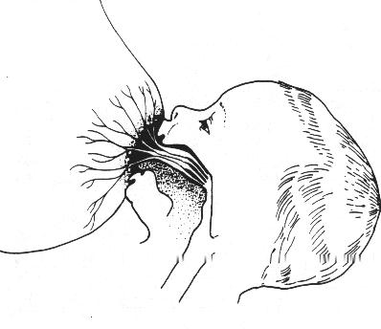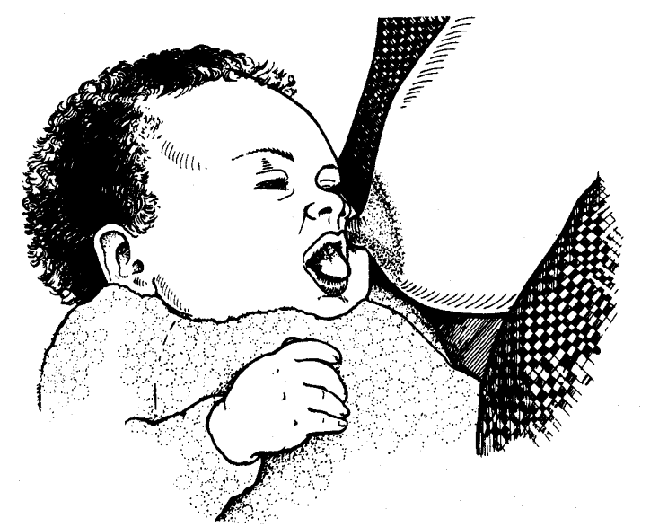

The baby on the left is attached well with mouth wide open getting milk from the ducts. His lower lip is turned out and his chin touches the breast.
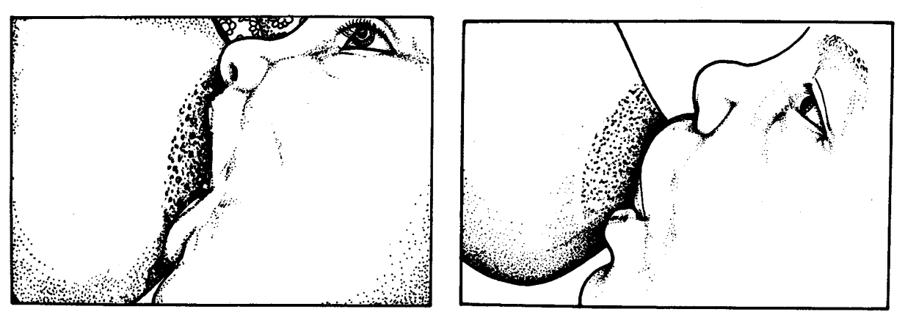
The baby on the right, has just the nipple in his mouth, causing the nipple to rub back and forth and become painful over time. Also, the milk is not getting squeezed out of the ducts.
How Do I Know my Baby is Getting Enough Milk?
You’ll want to breastfeed your baby whenever he’s hungry. For the first four weeks a baby will tend to breastfeed every 3-4 hours. Newborns may need to be woken up to feed. It’s important to not mistake normal pauses in suckling for being finished with a feed. You want to make sure he stays on the breast long enough to get the hindmilk. The best way to know your baby is getting enough milk is by watching him swallow when he breastfeeds and seeing the number of wet diapers increase from one on the first day to about 6-8 per day after the first week. Though all babies lose a little weight right after birth, they should be back up to their birth weight by two weeks. It’s important to weigh your baby naked with each immunization visit and record it in their baby book. If you have any concerns ask to see a clinic nurse or a clinician.
Why is my Baby Crying?
There can be many reasons for your baby to cry. If you have just fed your baby and he is still crying, check to see if he may be uncomfortable. Is he too hot? Too cold? Has he had a lot of visitors and may just need to sleep? Does his diaper need to be changed? Does your baby have a fever or seem to be sick? If so, bring him to the clinic and let us examine him. Some babies cry in response to something mom ate. Caffeine, cigarettes, and other drugs are the biggest problem. Some ‘high needs’ babies just like to be held and tend to cry at regular times, such as in the evenings. If a baby cries continuously at different times of the day, bringing his knees up to his chest like he’s in pain, and is not able to be soothed, he may have colic. The cause of colic is unknown, but most babies improve by 3 to 4 months. Here are some ways you can hold a crying baby to help soothe him: 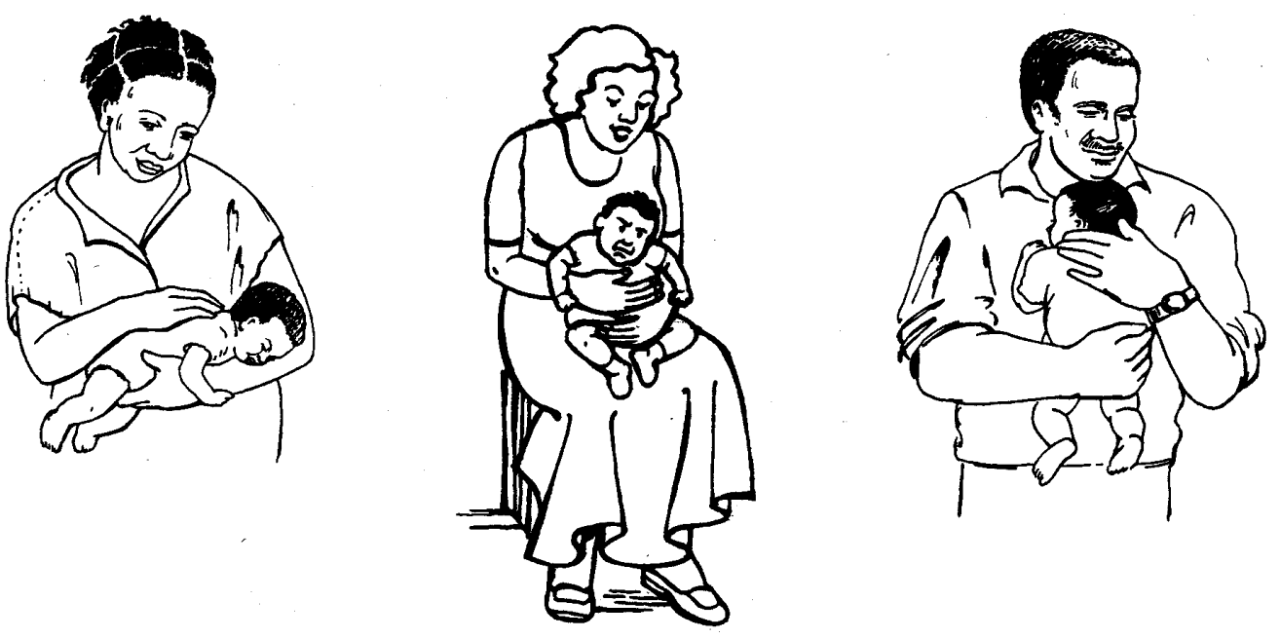

How do I Continue Breastfeeding and Return to Work?
If you plan to return to work while your baby is exclusively breastfeeding, it is important to make a plan. In general Malawian employers are supportive of breastfeeding mothers. If possible, arrange to meet your baby so you can breastfeed directly on your lunch break. It’s also important to learn how to manually express breastmilk so you can leave some for the caretaker to feed your baby by cup.

Expressing Breastmilk:
- Clean the cup or container out ahead of time with dish soap and water. Next, pour boiling water over the container.
- In order to stimulate the oxytocin reflex that releases the milk, you will want to think about your baby. If possible, skin to skin contact with baby is best. If not, maybe a picture or video of baby will help.
- You can prepare the breasts by putting warm compresses on the breast.
- Then stimulate the nipple by rubbing or rolling it.
- You can massage the breast with your fingertips, a comb, or a gently rolled fist.
- Pour the boiling water out of the cup and prepare to express the milk.
- To express the milk:
  - Place finger and thumb on each side of the areola and press inwards towards the chest wall.
  - Press behind the nipple and areola between your finger and thumb. Avoid squeezing the nipple itself.
  - Press from the sides to empty all the segments.
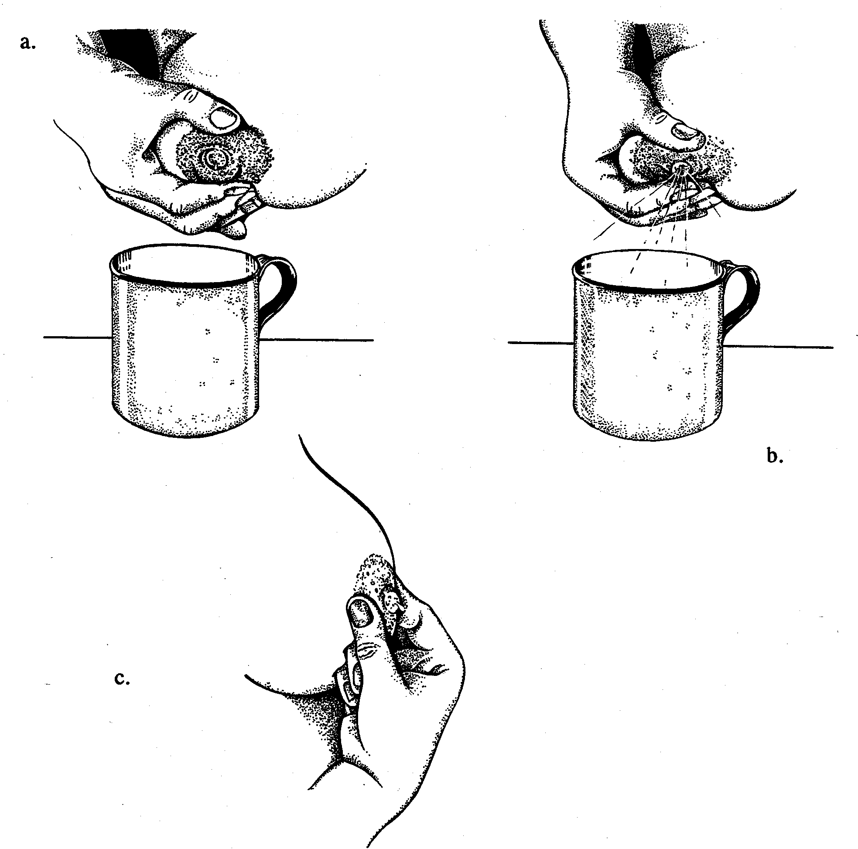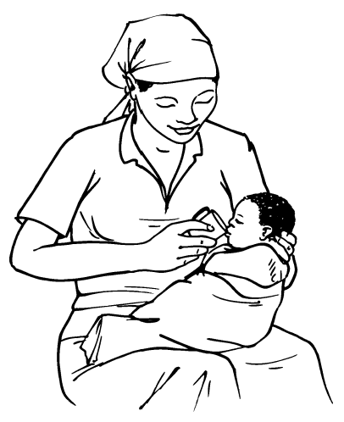

- Express one breast for 3-5 minutes until milk slows down, then go to the next breast. Repeat on both sides. It should take about 20-30 minutes.

Cup Feeds
- Wash your hands.
- Hold the baby sitting upright or semi-upright on your lap.
- Place the estimated amount of milk for one feed into the cup.
- Hold the small cup of milk to the baby's lips.
- Tip the cup so that the milk just reaches the baby's lips. The cup rests lightly on the baby's lower lip, and the edges of the cup touch the outer part of the baby’s upper lip. The baby becomes alert, and opens his mouth and eyes.
A low-birth-weight (LBW) baby starts to take the milk into his mouth with his tongue. A full term or older baby sucks the milk, spilling some of it.
DO NOT POUR the milk into the baby's mouth. Just hold the cup to his lips and let him take it himself.
- When the baby has had enough, he closes his mouth and will not take any more. If he has not taken the calculated amount, he may take more next time, or you may need to feed him more often.

Breastfeeding Concerns:
Inverted or Flat Nipples - Even mothers with flat or inverted nipples can breastfeed effectively. It may take more time and patience for Mom and baby to figure it out. Be sure to give yourself lots of skin to skin time, try different positions, and don’t be afraid to ask for help.
Growth Spurts – Babies tend to get growth spurts around 2 weeks, 6 weeks, and 3 months. They may cry and be more hungry. It is important to feed them more often for a few days, so that your milk supply will increase to meet their need.
Refusal to Feed – Sometimes baby may refuse to breastfeed. Perhaps Mom smells different, has changed the routine or eaten something baby doesn’t recognize. Or maybe baby’s nose is blocked up and it’s hard to breathe and feed. Try to find and correct the cause and go back to basics. Make sure you get lots of skin to skin cuddle time. Offer the breast whenever your baby seems interested. As a last resort, express and cup feed until baby is ready to resume breastfeeding.
Engorged Breasts- The breast can get so full of milk that it leaks into the surrounding tissue causing pain, redness, and even a 24 hour fever. The best way to solve this problem is to empty the breast. If breast is too swollen for your baby to latch on properly, express a little milk and try again. Warm compresses or hot shower before you feed and cold compresses after can help decrease swelling. To prevent engorgement, try to feed as soon as possible after delivery and as long and as much as baby wants to feed.
Sore Nipples – The most common cause of sore nipples is poor attachment. Sometimes you can get a cut or irritation on the nipple. Rub some breast milk on the end of the nipple after feeding to help it heal.
Blocked Ducts- A blocked duct will present as a tender, red, lump. You shouldn’t have a fever. You can massage the area to try to dislodge the plug as baby breastfeeds. If milk continues to stay in the breast or there is a cut on the nipple that allows bacteria to enter, you can develop a breast infection, called mastitis.
Mastitis – This is a breast infection that is characterized by severe pain, fever, red area, and generally feeling quite sick. It’s important to go to the clinic to be seen.
Candida Infection – A candida infection on the breast feels like sharp pains, like pins and needles in the breast. This needs to be seen and treated from the clinic.
HIV and Breastfeeding – Malawi guidelines advise all HIV positive pregnant women to be on ARTs. This decreases the chance of transmitting HIV to the baby through breastfeeding so much that Malawi advises HIV positive moms should breastfeed as well.
Any Concerns – At ABC Community Clinic we want to do everything we can to encourage and assist you to breastfeed exclusively for the first 6 months and up to 2 years and beyond once complementary foods are added. If you have any concerns, including HIV and breastfeeding, please come see us and let us find a solution together.
Written June 2020, from World Health Organization. Combined course on growth assessment and IYCF counselling. Geneva, WHO, 2012.

